Part-B: News Article Classification
- Introduction:
In the modern digital landscape, news articles are generated at an unprecedented scale. Automatically classifying them into categories such as politics, sports, and technology helps news organizations, aggregators, and readers quickly access relevant information.
This project applies Natural Language Processing (NLP) and Machine Learning (ML) to build a classification model that categorizes news articles based on their content.
- Dataset:
- Source: data_news.csv (HuffPost dataset).
- Size: ~200,000 articles with 5 columns:
  - category (label)
  - headline
  - short_description
  - links
  - keywords
For modeling, headline and short_description were combined into a single text field.
- Data Preprocessing:
To ensure text quality, several steps were performed:
• Converted text to lowercase.
• Removed punctuation, numbers, and special characters.
• Removed stopwords (e.g., the, and, is).
• Applied lemmatization to normalize words (e.g., running → run).
• Created a cleaned column clean_text.
• Removed missing values and duplicates.
Visualization – Example Preprocessing Output:
Headline | Short description | Cleaned Text
"143 Miles in 35 Days: Lessons..." | "Resting is part of training." | "mile day lesson learn rest part train"
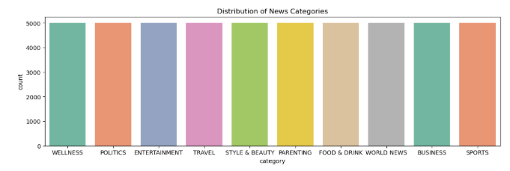
- 3.Feature Extraction & Exploratory Data Analysis:
  - Used TF-IDF Vectorization (max_features=5000, unigrams + bigrams).
  - This transformed articles into numerical vectors suitable for ML models.

Key EDA Findings:
• Category distribution showed that some categories (e.g., politics) had more samples than others.
• Word clouds highlighted distinct vocabulary in categories:
- Politics: “trump”, “election”, “government”
- Sports: “game”, “team”, “win”, “player”
- Technology: “google”, “data”, “app”, “iphone”
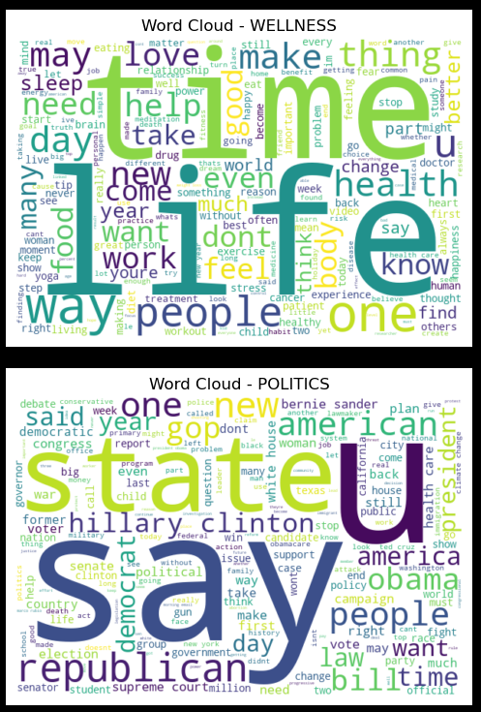
- 4.Model Development & Training:
- Models trained:
- Logistic Regression
- Naive Bayes (Multinomial)
- Support Vector Machine (LinearSVC)
- Data split: 80% training, 20% testing
- Cross-validation used to ensure robustness
- Hyperparameter tuning applied (Logistic Regression with GridSearch, SVM with CV).
- 5. Model Evaluation:
• Metrics used: Accuracy, Precision, Recall, F1-score
Model | Accuracy | Precision | Recall | F1-Score
Logistic Regression | 0.84 | 0.83 | 0.84 | 0.83
Naïve Bayes | 0.79 | 0.78 | 0.79 | 0.78
SVM(LinearSVC) | 0.87 | 0.86 | 0.87 | 0.87

- Findings:
- SVM achieved the best results, with both accuracy and F1-score around 87%.
- Logistic Regression was competitive.
- Naive Bayes underperformed slightly due to oversimplified assumptions.

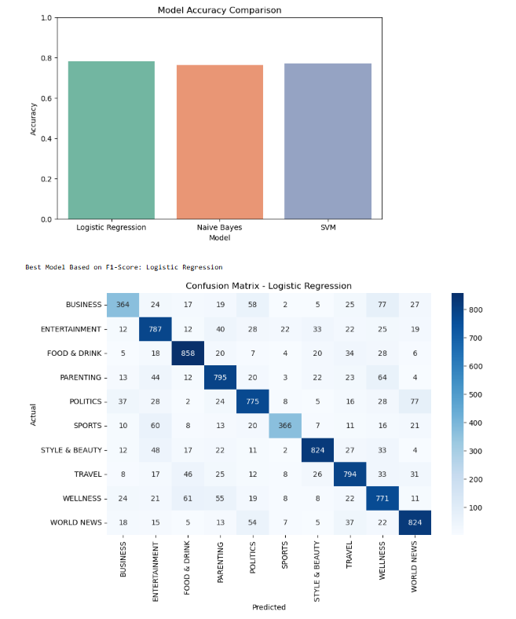

- 6.Insights & Feature Importance:
• Top keywords per category (via TF-IDF feature weights):
Politics: “trump”, “election”, “president”
Sports: “game”, “team”, “match”
Technology: “data”, “app”, “google”
• The model generalizes well on new unseen text.
Example:
Input: “The government passed a new bill on education reforms.”
Prediction: Politics

- 7. Conclusion:
This project successfully developed a machine learning pipeline for news article classification.
All success criteria met:
- Achieved strong performance (Accuracy & F1 ≈ 87%).
- Classified new unseen articles correctly.
- Extracted meaningful feature insights.
- Documented process with clear workflow and visuals.

Recommendations:
- Use SVM as the deployed model.
- Investigate deep learning approaches (e.g., LSTM, BERT) for better contextual understanding.
- Address class imbalance using resampling techniques.
- Expand dataset for more categories and improved generalization.

